**Online Department Management System**

**A Research Project Submitted in Partial Fulfilment of the Requirement for the Degree of Bachelor of Science (Engineering) in Computer Science and Engineering**

**Submitted By**

Hossain Shahid Shahriar

ID: CE16017  
Session: 2015-2016

&

S.M. Abdus Salam

ID: CE14036

Session: 2013-14

**Supervised By**

Mohd. Sultan Ahammad

Lecturer

Dept. of CSE, MBSTU



**Department of Computer Science and Engineering**

**Mawlana Bhashani Science and Technology University**

Santosh, Tangail-1902, Bangladesh.

**Approval**

This is to certify that the project work submitted by Hossain Shahid Shahriar(CE-16017) and S.M. Abdus Salam (CE-14036) session 2015-16 to the Department of Computer Science and Engineering, Mawlana Bhashani Science and Technology University, Santosh, Tangail-1902. Bangladesh has been accepted as satisfactory for the partial fulfillment of the requirement for the degree of Bachelor of Science in Computer Science and Engineering and approved as to its styles and contents.

**Board of Examiners**

1. Mohd. Sultan Ahammad

Lecturer …………………..

Department of CSE Supervisor

MBSTU, Tangail-1902

1. Dr. Md. Sazzad Hossain

Associate Professor …………………..

Department of CSE Chairman

MBSTU, Tangail-1902 Examination Committee

……..………………………..

Member (External)

Examination Committee

**Declaration**

We, hereby, declare that the project work presented by us is the outcome of our project under the supervision of Mohd. Sultan Ahammad, Lecturer, Department of Computer Science and Engineering, Mawlana Bhashani Science and Technology, Santosh, Tangail-1902, Bangladesh.

We also declare that no part of this project and thereof has been or is being submitted elsewhere for the award of any degree or diploma.

Name ID Signature

Hossain Shahid Shahriar CE16017 …………….....

S.M. Abdus Salam CE14036 …………….....

**Acknowledgment**

First of all, we would like to thank almighty Allah who gave us the ability and guidance to complete our work.

We would like to express our sincere appreciation to Mohd. Sultan Ahammad, our respected supervisor for his valuable guidance and insight, encouragement, and support throughout the project work. His comments and guidance helped us a lot in preparing our project report.

We are also grateful to our teachers of Computer Science and Engineering department who have helped us by giving various suggestions at different times.

Finally, our special thanks go to authors whose works have been incorporated into our project.

**Contents**

Page No.

**Approval** ……………………………………………… **II**

**Declaration** ……………………………………………… **III**

**Acknowledgments** ……………………………………………… **IV**

**Contents** ……………………………………………… **V**

**Abstract** ……………………………………………… **V-VI**

**Table of Content** ……………………………………………… **VI-VIII**

**Table of Figure** ……………………………………………… **IX-X**

**Abstract**

This document is meant for describing all the features and procedures that were followed while developing the system. This document specially mentions the details of the project and how it was developed, the primary requirement, as well as various features and functionalities of the project and the procedures followed in achieving these objectives. Over the years the manual Department Management System has been carried across most of educational institutions. To overcome the problems of manual management, we have developed “web based Department Management System”. In this application, PHP is server side language, MySQL and Laravel is used as back-end design and HTML, CSS, Bootstrap and JavaScript are used as front-end tools. The system communicates with database residing on a remote server. It calculates automatically, the attendance percentage of students without any manual paper-based work. The system facilitates the end users with interactive design and automated processing. With the effective use, any Institute can apply the “Department Management System” for conducting quick management and getting better results in less time.

**Table of Content**

Chapter: 1 Introduction 1

1.1 Project Definition 1

1.2 Project Motivation 1

1.3 Project Purpose 1

1.4 Project Scope 2

1.5 Project Goals 2

Chapter: 2 Project Description & Criteria 3

2.1 Project Perspective 3

2.2 Advantage of this System 3

2.3 System Analysis 4

2.4 Analysis Model 4

2.5 Graphical User Interface 6

2.6 Number of Modules 7

2.7 System Planning 8

2.8 Technical Feasibility 9

2.9 Operational Feasibility 9

2.10 Economic Feasibility 9

Chapter: 3 Requirements 10

3.1 Project Requirement 10

3.2 Tools and Software Requirement 10

3.3 Hardware Requirement 10

Chapter: 4 Project Design 11

4.1 Dataflow Diagram 11

4.2 Use case Diagram 12

4.3 Class Diagram 17

Chapter: 5 Technical Tools 18

5.1 Visual Studio Code Editor 18

5.2 Laravel framework 19

5.3 MySQL database 20

5.4 Xampp server 21

Chapter: 6 Testing, Security, and Maintenance 21

6.1 Methodology used for Testing 21

6.1.1 Testing methods 21

6.1.1.1 Black box testing 22

6.1.1.2 White box testing 22

Chapter: 7 Security 22

6.3 Maintenance 23

Chapter: 8 Project Implementation and Functionality 24

8.1 Login Form 24

8.2 Admin Dashboard 25

8.2.1 Upload Information 26

8.2.2 Add Information 28

8.2.3 Delete Information 28

8.2.4 Update Information 30

8.2.5 Assign Teacher 31

8.2.6 Browse Information 32

8.2.7 Set/Update Teacher Priority 33

8.2.8 Archive Documents 34

8.3 Teacher Dashboard 35

8.3.1 Teacher Assigned Courses 36

8.3.2 Create Class 37

8.3.3 View Students Attendance Results 38

8.3.4 Routine 39

8.3.5 Archived Files 40

8.4 Student Dashboard 41

8.4.1 Courses 42

8.4.2 Attendance Page 43

8.4.3 Result Page 44

8.4.4 library 45

8.4.5 Routine 46

8.4.6 Archived Files 47

8.5 Library Dashboard 48

8.5.1 Upload Page 49

8.5.2 Update/Delete Page 50

Chapter: 9 Limitations, Future Work and Conclusion 51

9.1 Limitations 51

9.2 Future Works 51

9.3 Conclusion 51

Chapter: 10 References 52

**Table of Figures**

Figure 4.1.1: Level 0 Data Flow Diagram 11

Figure 4.1.2: Level 1 Data Flow Diagram 12

Figure 4.2.1: Use case Diagram of Admin 13

Figure 4.2.2: Use case Diagram of Teacher 14

Figure 4.2.3: Use case Diagram of Student 15

Figure 4.2.4: Use case Diagram of Librarian 16

Figure 4.3.1: Class Diagram 17

Figure 7.1: Login Form 24

Figure 7.2.1: Admin Dashboard 25

Figure 7.2.2: Upload Information 26

Figure 7.2.3: Add Information 27

Figure 7.2.4: Delete Information 28

Figure 7.2.5: Update Information 29

Figure 7.2.6: Assign Teachers 30

Figure 7.2.7: Browse Information 31

Figure 7.2.8: Set/Update Teacher Priority 32

Figure 7.2.9: Set/Update Teacher Priority 33

Figure 7.3.1: Teacher Dashboard 34

Figure 7.3.2: Courses 35

Figure 7.3.3: Create Class 36

Figure7.3.4: Students Result 37

Figure 7.3.5: Routine 38

Figure 7.3.6: Archived Flies 39

Figure 7.4.1: Student Dashboard 40

Figure 7.4.2: Courses 41

Figure 7.4.3: Attendance Page 42

Figure 7.4.4: Result Page 43

Figure 7.4.5: Library 44

Figure 7.4.6: Routine 45

Figure 7.4.7: Archived Flies 46

Figure 7.5.1: Library Dashboard 47

Figure 7.5.2: Upload Page 48

Figure 7.5.3: Update/Delete page 49

# Introduction

This chapter makes an introduction to Online Department Management System motivation, purpose, scope, and goals of our project. At the end organization of this research, the book is described.

## Project Definition

A centralized online department management system is a single computerized storage place with resources can be accessed via an internet and can be assisted to the teacher’s students and staffs to provide service and maintain organizational databases via web interfaces. Furthermore, a computerized management system in a department helps to collect, process, store, and distribute resources.

In addition to that, Department management system can be used to handle the student attendance system.

## Project Motivation

Universities are maintaining departmental activities with the minimum computerized system or manual system using MS-excel and MS-word, which leads to error-prone and time consuming.

Therefore, this project provides an error-free and fully computerized online department management system for the universities using various web and database technologies to avoid these issues.

## Project Purpose

This project purpose is to provide various records regarding students in aspects of Attendance, Progress, information management, and many more. It becomes easier for department and other staff to keep the department records related to all the candidates without manual paperwork. Retrieval of information with respect to any single or multiple record name of the student or particular class helps in aiding the management. Report generations of particular student, class helps in drawing easier conclusions over the status or progress of the candidate.

## Project Scope

Universities existing for more than centuries, continuously provide various fields such as medical, engineering, social sciences, and much more to support the development of the country.

The quality of this education system depends on assessment methods and services providing by the relevant department.

Therefore, the services providing by the department are announcements, results generation, final grading from lecturers, student status, documents from departments on student request must be available error-free, anytime, and anywhere.

In that sense, a centralized online department management system is a single computerized online place with resources can be accessed from anywhere.

## Project Goals

This project is fully focused on Online Department Management. It helps us for computerize the student management, attendance management, department maintenance, library management and online resources. Thereby we can easily access and maintain our department from wherever over the internet connection.

# Project Description & Criteria

## Project Perspective

This project will minimize the time and reduce the complexity of the existing system. We believe that it improves the management of department. We provide an open platform to manage department very easily and more reliable. It is very secure and highly transparent for teachers and students.

## **Advantage of this System**

This application reduces the complexity of the existing manual system. These advantages are given below:

* **Accessibility:** This application can be accessed from any computer or any mobile device regardless of platform.  All files can be maintained by the admin from anywhere. Users can access the application anytime, anywhere. Students have to attend class in a given time.
* **Low Maintenance Cost:** Most available solution has a great disadvantage for implementation and requires high cost infrastructure with limited functionality like biometrics, bar code scanner etc. This application successfully reduced cost as well as time.
* **Paperless:** Teachers and won’t have excessive amounts of paper to shuffle since this application provides online student attendance system which is completely paperless. Admin can upload files and resources to the application, they are simultaneously saved to the local storage. Teachers can view files directly through this application.
* **Time Saver:** This application saves huge times. With all resources saved in one place and the ability to access the application anywhere, teachers will have more free time to complete other tasks. Since the application can be accessed from a mobile device, teachers and students can participate through their phones or tablets.
* **Efficient Access:** In this application different type of users (Admin, Teachers, Students, Librarian) can access their dashboard more securely and easily and play their specific role.
* **Collaborate:** Our application offers several ways of user’s collaboration. Teachers can make class and take attendance and students can give attendance. Admin can archive departmental documents and teachers can view and download them.

## System Analysis

In this section, the software’s overall structure and its nuances are outlined. In terms of client-server technology, no tiers are defined in this section. The tiers which are needed for the package architecture, database design, data structure design, etc. are well defined in this phase. Analysis and Design are a very crucial part of the entire development cycle management. Any flaw during this section may be expensive to solve in the later stage of software development.

A user interface is a very important part of a system with which the users interact. It includes the screen displays that provide navigation through the system, the screens and forms that capture data, and the reports that the system produces.

## Analysis Model

This document plays a vital role in the development of the life cycle (SDLC) as it describes the complete requirement of the application. It also contains information about the building code that structures use in the load combination process. It is used for analyzing structural behavior and load-bearing, and for design. It means for use by developers and will be the basic during the testing phase. Any changes made to the requirements in the future will have to go through a formal change approval process.

SPIRAL MODEL was defined by Barry Boehm in his 1988 article, A Spiral Model of Software Development and Enhancement. This model was not the first model to discuss iterative development, but it was the first model to explain why the iteration models. The spiral model is a risk-driven process model generator for software projects. This spiral model is a combination of the iterative development process model and sequential linear development model. As originally envisioned, the iterations were typically 6 months to 2 years long. Each phase starts with a design

goal and ends with a client reviewing the progress thus far. Analysis and engineering efforts are applied at each phase of the project, with an eye toward the end goal of the project.

**The steps for the Spiral Model can be generalized as follows:**

* The new system requirements are defined in as many details as possible. This usually involves interviewing several users representing all the external or internal users and other aspects of the existing system.
* A preliminary design is created for the new system.
* A prototype of the new system is constructed from the preliminary design. This is usually a scaled-down system and represents an approximation of the characteristics of the final product.
* A second prototype is evolved by a fourfold procedure:
* Evaluating the prototype in terms of its strengths, weakness, and risks.
* Defining the requirements of the second prototype.
* Planning and designing the second prototype.
* Constructing and testing the second prototype.
* At the customer option, the entire project can be aborted if the risk is deemed too great. Risk factors might involve development cost overruns, operating-cost miscalculation, or any other factor that could, in the customer’s judgment, result in a less-than-satisfactory final product.
* The existing prototype is evaluated in the same manner as was the previous prototype, and if necessary, another prototype is developed from it according to the fourfold procedure outlined above.
* The preceding steps are iterated until the customer is satisfied that the refined prototype represents the final product desired.
* The final system is constructed, based on the refined prototype.

The final system is thoroughly evaluated and tested. Routine maintenance is carried continuously to prevent large-scale failures and to minimize downtime.

## Graphical User Interface

In the flexibility of the uses, the interface has been developed with a graphics concept in mind, associated through a browser interface. GUI is a program interface that takes advantage of the computer's graphics capabilities to make the program easier to use. Many users find that they work more effectively. The GUI at the top level have been categorized as

• Administrative user interface

• The operational or generic user interface

The administrative user interface concentrates on the consistent information that is practical, part of the organizational activities, and which needs proper authentication for the data collection. The interfaces help the administrations with all the transactional states like Data insertion, Data deletion, Date up-gradation, Reporting, and helpline for the users along with the extensive data search capabilities. The operational or generic user interface helps the users upon the system in transactions through the existing data and required services. The operational user interface also helps the ordinary users in managing their own information helps the ordinary users in managing their information in a customized manner as per the assisted flexibilities.

## Number of Modules

This application consists of the following modules. Modules are divided based on user type. We have two types of users as Teacher and Student. So the modules are:

**General Modules:**

* User Login
* Update Password
* Logout

**Admin Modules:**

* Upload Information
* Add Information
* Delete Information
* Browse Information
* Update Information
* Assign Techers to Courses
* Archived Files
* Update Teacher Priority

**Student Modules:**

* View Courses
* View Result
* Give Attendance
* Update Email
* Library
* Routine
* Archived Files

**Teacher Modules:**

* View Courses
* Make Class
* View and Download Result
* Update Email
* Set and View Routine
* Library
* Archived Files

**Librarian Modules:**

* Upload Books Information
* Update Books Information
* Delete Books Information
* Search Books

## System Planning

Project planning is the application of knowledge, skill, tools, and techniques to the project activities to fulfill the project requirements. Perform and evaluate feasibility studies like cost-benefit analysis, technical feasibility, time feasibility, and operational feasibility for the project. A feasibility study is carried out to decide whether the proposed system is feasible for the company. The feasibility study is to serve as a decision document it must answer three

Key questions:

1. Is there a new and better way to do the job that will benefit the user?

2. What are the cost and the savings of the alternative(s)?

3. What is recommended?

## Technical Feasibility

Technical Feasibility centers on the existing computer system hardware, software, etc. and to some extent how it can support the proposed addition. This involves financial considerations to accommodate technical enhancements. Technical support is also a reason for the success of the project. Since the project is designed with the Laravel framework which is based on PHP, JavaScript, JQuery, CSS, Bootstrap as the Front end, and MySQL as data storage, it is easy to install in all the systems wherever needed. It is more efficient, easy, and user-friendly to understand by almost everyone.

A huge amount of data can be handled efficiently using the local database as the back end.

Hence this project has good technical feasibility.

## Operational Feasibility

People are inherently instant to change and computers have been known to facilitate change. An estimate should be made as to how strong a reaction the user staff is likely to have towards the development of the computerized system.

The staff is accustomed to computerized systems. These kinds of systems are becoming more common day by day for evaluation of the software engineers. Hence, this system is operationally feasible. As this system is technically, economically, and operationally feasible so this system is judged feasible.

## Economic Feasibility

Economic feasibility is mainly concerned with the cost incurred in the implementation of the software. Since this project is developed using Spring and Local Database which is more commonly available and even the cost involved in the installation process is not high. Similarly, it is easy to recruit persons for operating the software since almost all the people are aware of Java and Spring with some knowledge of Local Database. Even if we want to train the persons in these areas the cost involved in training is also very less. Hence this project has good economic feasibility.

# **Requirements**

## Project Requirement

* Complete Interaction Diagram.
* Complete source code and runtime files for both the front end and back end.
* Complete database re-generation script.
* A project paper illustrating the scope of my work, statement of problems, approach, and methodology adopted for software development, and brief analysis of the advantage of my system.

## Tools and Software Requirement

* Any good web browser. E.g.: Google Chrome, Mozilla Firefox.
* PHP 7.4 or above.
* Visual Studio Code IDE.
* Laravel framework.
* MySQL using MySQL connector API.
* Xampp as the database server.

## Hardware Requirement

* Processor with 1.3 GHz clock speed or above.
* RAM with 2 GB memory or above.
* ROM with a minimum of 3 GB free space remaining.

# **Project Design**

## Dataflow Diagram

**Level 0 of Online Department Management System**

It is also known as a context diagram. It’s designed to be an abstraction view, showing the system as a single process with its relationship to external entities. It represents the entire system as a single bubble with input and output data indicated by incoming/outgoing arrows.

**Admin Module**

**Admin**

**Teacher Module**

**Teacher**

**Student Module**

**Student**

**Library Module**

**Librarian**

##### Figure 4.1.1: Level 0 Data Flow Diagram

**Level 1 of Online Department Management System**

In 1-level DFD, the context diagram is decomposed into multiple bubbles/processes. In this level, we highlight the attendance system and breakdown the high-level process of 0-level DFD into sub-processes.

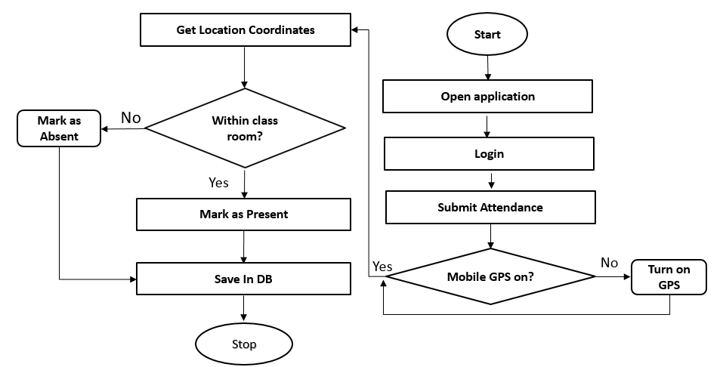

##### Figure 4.1.2: Level 1 Data Flow Diagram

## Use case Diagram

Use case diagram is one of the parts of Unified Modeling Language. Its nature is dynamic and it has a graphic depiction of the interactions of internal or external factors. The use case is used in system analysis to identify, clarify, and organize system requirements. A use case diagrams one kind of a flowchart. Instinctive symbols represent the system elements which are like an actor, use case, association, includes relationship.

**Use case Diagram of Admin:**

Admin

##### Figure 4.2.1: Use case Diagram of Admin

**Use case Diagram of Teacher:**

Teacher

##### Figure 4.2.2: Use case Diagram of Teacher

**Use case Diagram of Student:**

Student

##### Figure 4.2.3: Use case Diagram of Student

**Use case Diagram of Librarian:**

Librarian

##### Figure 4.2.4: Use case Diagram of Librarian

## Class Diagram

The class diagram is the main building block of object-oriented modeling. It is used for general conceptual modeling of the structure of the application, and detailed modeling translating the models into programming code.

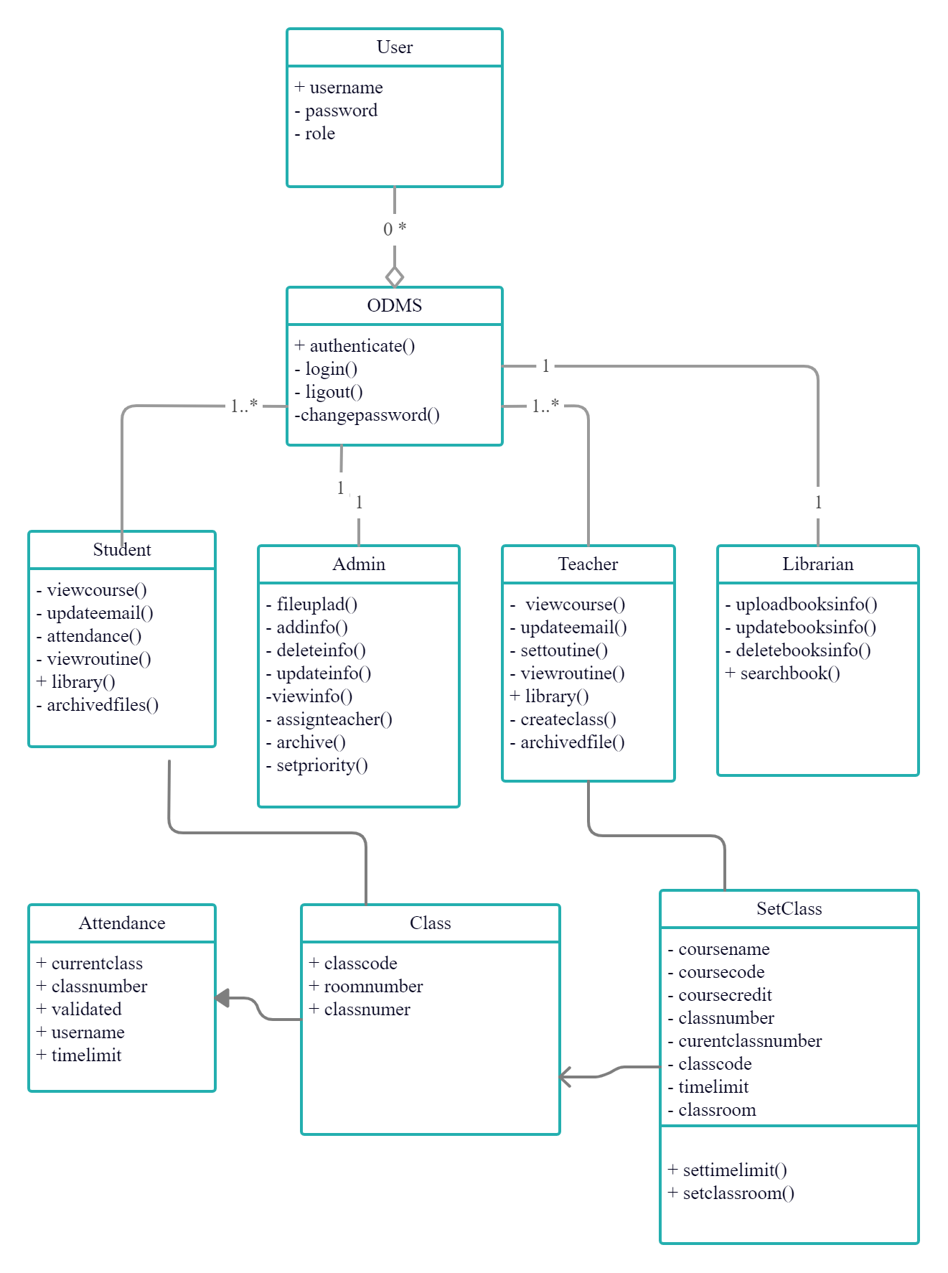

##### Figure 4.3.1: Class Diagram

# **Technical Tools**

Technical tools are like construction kits, parser generators, lexical analyzer/analyzer generators, code optimizers (optimizer generators), provide the facility where you define your language and allow the compiler creation tools to generate the source code for your software.

For creating the application Online Department Management System, we use Visual Studio Code Editor and the Laravel framework. For backend code, we use MySQL and Xampp as database servers.

## Visual Studio Code Editor

Visual Studio Code is a lightweight but powerful source code editor which runs on your desktop and is available for Windows, macOS and Linux. It comes with built-in support for JavaScript, TypeScript and Node.js and has a rich ecosystem of extensions for other languages (such as C++, C#, Java, Python, PHP, Go) and runtimes (such as .NET and Unity).

VS Code uses the official PHP linter (php -l) for PHP language diagnostics. This allows VS Code to stay current with PHP linter improvements.

There are three settings to control the PHP linter:

* php.validate.enable: controls whether to enable PHP linting at all. Enabled by default.
* php.validate.executablePath: points to the PHP executable on disk. Set this if the PHP executable is not on the system path.
* php.validate.run: controls whether the validation is triggered on save (value: "onSave") or on type (value: "onType"). Default is on save.

To set the PHP executable path, select the **Edit in settings.json** link under **PHP > Validate: Executable Path**, which will open your user settings.json file. Add the php.validate.executablePath setting with the path to your PHP installation:

Windows:

{

"php.validate.executablePath": "c:/php/php.exe"

}

Linux and macOS:

{

"php.validate.executablePath": "/usr/bin/php"

}

## Laravel framework

Laravel is a web application framework with expressive, elegant syntax. A web framework provides a structure and starting point for creating your application, allowing you to focus on creating something amazing while we sweat the details.

Laravel strives to provide an amazing developer experience while providing powerful features such as thorough dependency injection, an expressive database abstraction layer, queues and scheduled jobs, unit and integration testing, and more.

Why use Laravel:

* A Progressive Framework
* A Scalable Framework
* A Community Framework
* Offer Best Packages in the PHP ecosystem

## MySQL database

* MySQL is an Oracle-backed open-source relational database management system (RDBMS) based on Structured Query Language (SQL). MySQL runs on virtually all platforms, including Linux, UNIX, and Windows. Although it can be used in a wide range of applications, MySQL is most often associated with web applications and online publishing.
* MySQL is an important component of an open-source enterprise stack called LAMP. LAMP is a web development platform that uses Linux as the operating system, Apache as the webserver, MySQL as the relational database management system, and PHP as the object-oriented scripting language. (Sometimes Perl or Python is used instead of PHP.)
* Originally conceived by the Swedish company MySQL AB, MySQL was acquired by Sun Microsystems in 2008 and then by Oracle when it bought Sun in 2010. Developers can use MySQL under the GNU General Public License (GPL), but enterprises must obtain a commercial license from Oracle.

## Xampp server

XAMPP is one of the widely used cross-platform web servers, which helps developers to create and test their programs on a local webserver. It was developed by the **Apache Friends**, and its native source code can be revised or modified by the audience. It consists of **Apache HTTPServer, MariaDB, and interpreter** for the different programming languages like PHP and Perl. It is available in 11 languages and supported by different platforms such as the IA-32 package of Windows & x64 package of macOS and Linux.

# **Testing, Security, and Maintenance**

## Methodology used for Testing

Completion of a software application will be achieved its fulfillment only after it has been thoroughly tested. It makes a feeling that the project of this application is completed. Projects cannot go through without this stage. Actually, in this stage, we can decide whether the project can run in the real-time environment execution without any breakdowns.

### Testing methods

Software testing methods are traditionally divided into two methods which are black-box testing and white box testing. These two methods are used to describe the testing results from the point of view of those methods.

#### Black box testing

In black-box testing, the whole software is treated as a “black box” without any knowledge of the internal implementation. Black box testing methods are a combination of some methods which are given below:

* Equivalence partitioning
* Boundary value analysis
* All-pairs testing
* Fuzz testing
* Model-based testing
* Traceability matrix
* Exploratory testing
* Specification-based testing

#### White box testing

When tester access to the internal data structure and algorithm white box testing works as a contrast to black-box testing. The white box testing method is also used as an evaluation of the completeness of the test suit that was created with the black box testing. The software team is allowed to examine all the parts of the software and ensures that the most important functions have been tested. There are some other methods outside of these traditional testing methods. These are:

* Gray Box Testing
* Acceptance Testing
* Regression Testing
* Non-functional Testing

The use of these tests varied on Software companies or the market of software.

# Security

This project contains a high level of security as a software system required there has three types of users as Author, Admin, and Reviewer with their securities. Anyone without authentication can’t use any secure operation in this application. No user can’t edit the system database or system except his changeable information like user name. Admin can’t access to show user's password.

## 6.3 Maintenance

When we start to complete Software Development Life Cycle we find a stage called Software maintenance. Software maintenance is a term used in software engineering when the software is delivered, like correction, bug fix, performance increase. Software is applying based on the real world. So when the real world changes we need to change the model of software. There are multiple reasons that software might need maintenance. Market conditions, client needs, host needs, organization structure change, or even the need to reset the software to the initial condition it was. So the main purpose of software maintenance is to correct faults after delivery and update and modify software applications when demand is changed based on the real world. Improve performance or other attributes are also part of software maintenance. Software maintenance could differ in many ways.

Based on the size and the nature of maintenance there are four types of maintenance.

* **Corrective maintenance**:

Ideals with a simple bug fix, spelling check, or modification requested in user report.

* **Adaptive maintenance:**

It may conclude system upgrade or keeping the software up to date with the latest features and trends.

* **Perfective maintenance:**

This might be related to a new feature upgrade, keep the software useable, or scale the software for new users.

* **Preventive maintenance:**

It ensures the safety of the software in the future, some modifications that aren't necessary for the present condition but could be a bigger problem some modification or maintenance might be necessary.

# Project Implementation and Functionality

## Login Form

In this application there are mainly four types of user’s students, teachers, admin and librarian. All have a few common features and most are different. A general view of the application form for all users is given below.

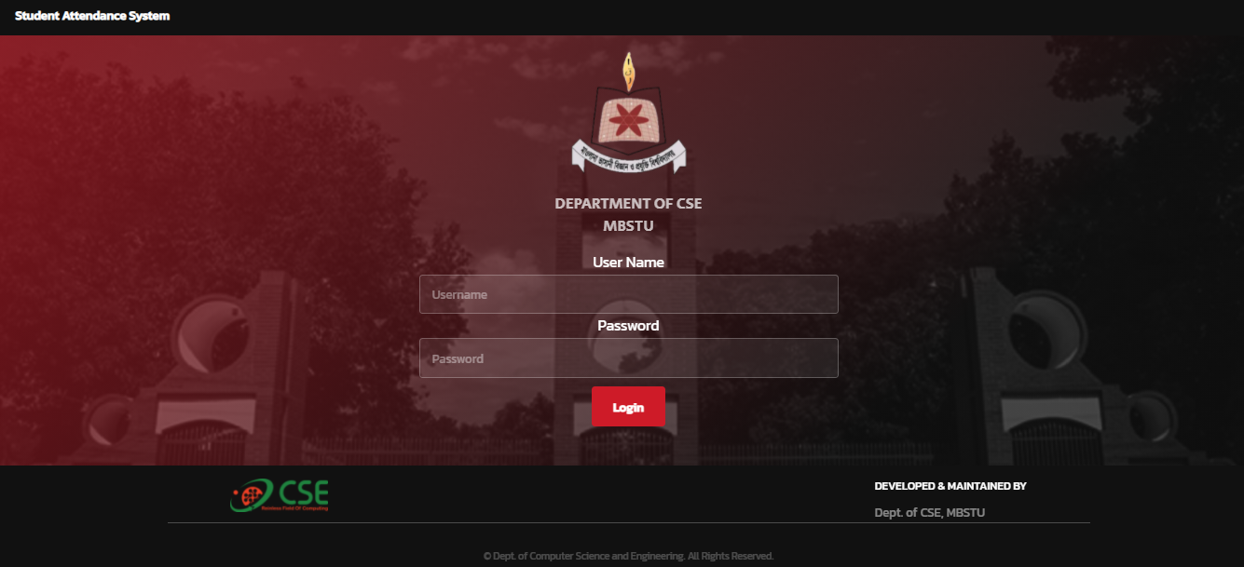

##### Figure 7.1: Login Form

## Admin Dashboard

After a successful login, admin dashboard will be shown.

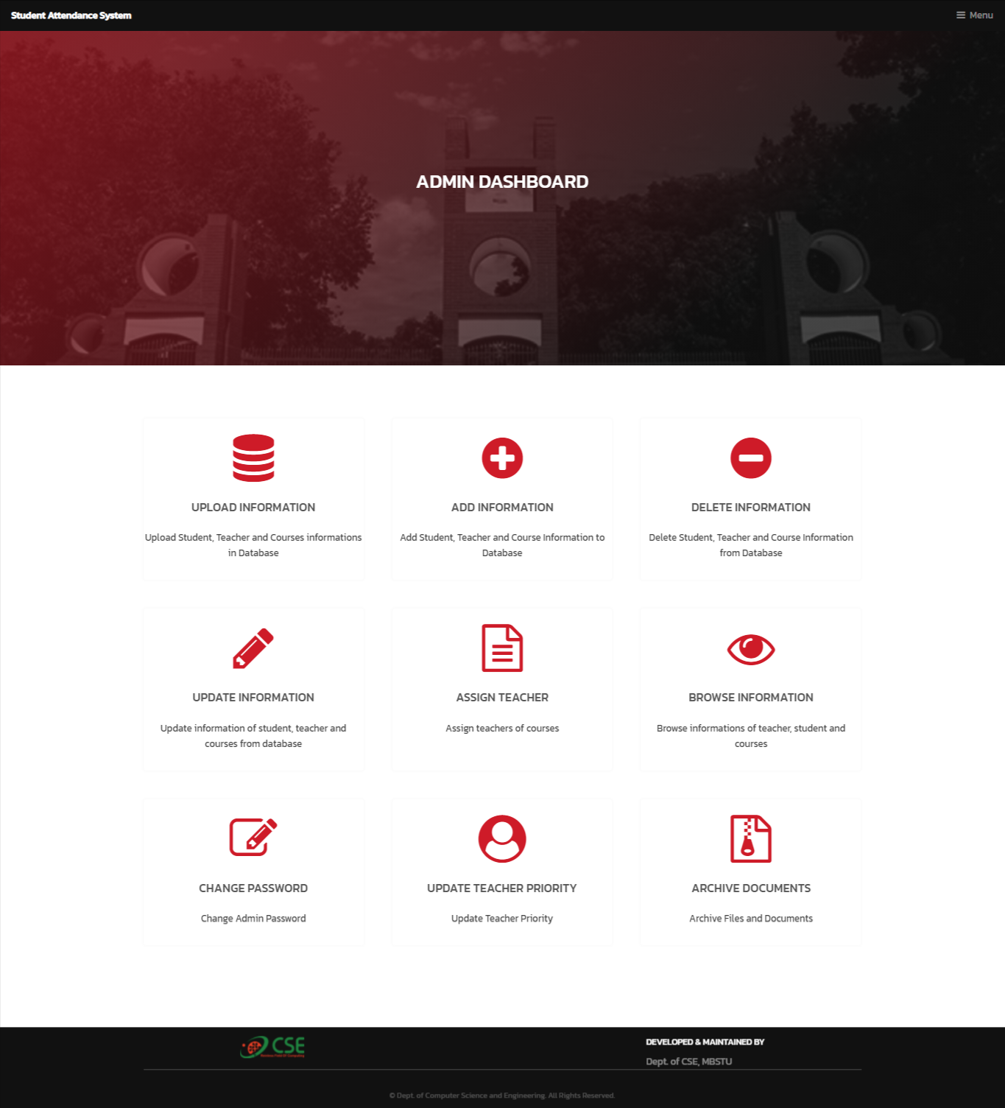

##### Figure 7.2.1: Admin Dashboard

### Upload Information

Admin can upload student, teacher and course information as excel file.

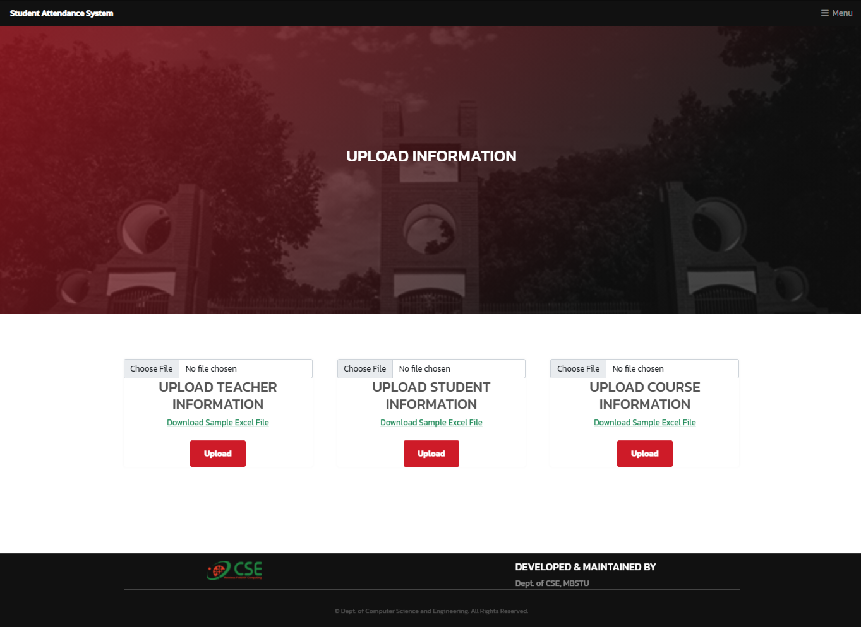

##### Figure 7.2.2: Upload Information

### Add Information

Admin can add teacher, teacher, course and class room here.

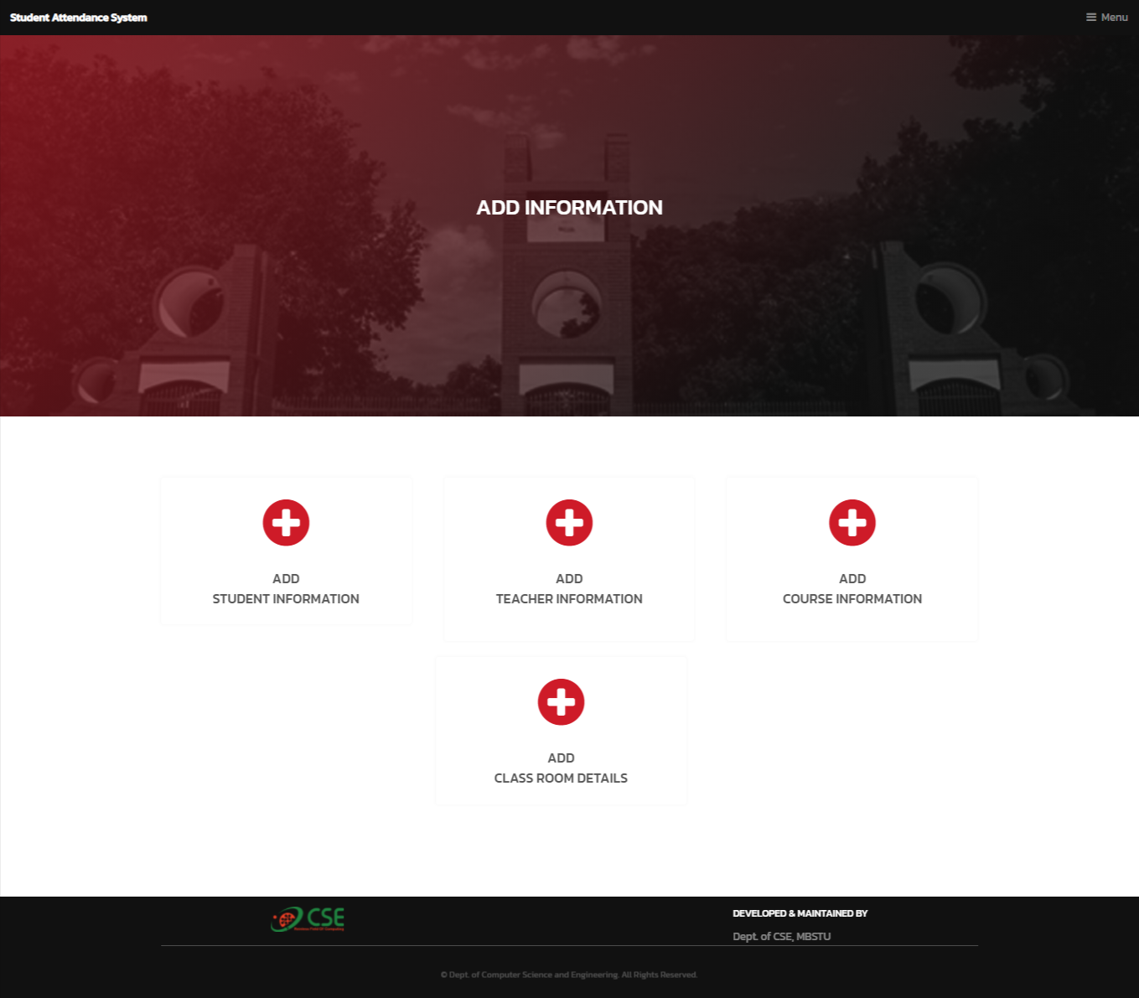

##### Figure 7.2.3: Add Information

### Delete Information

Admin can delete student, teacher, course and class room information here.

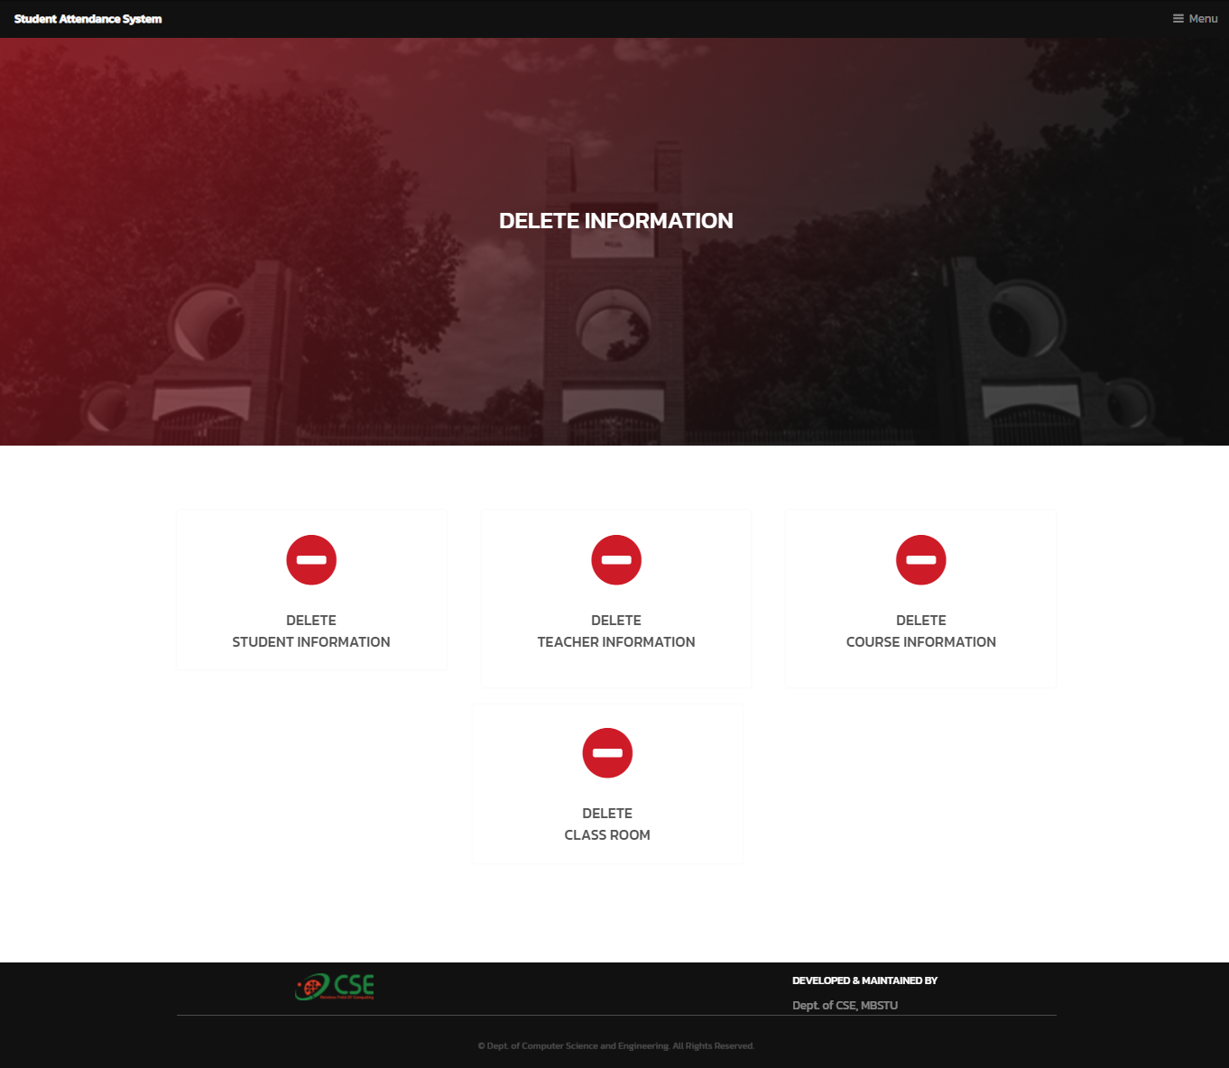

##### Figure 7.2.4: Delete Information

### Update Information

Admin can update student, teacher, course and class room information here.

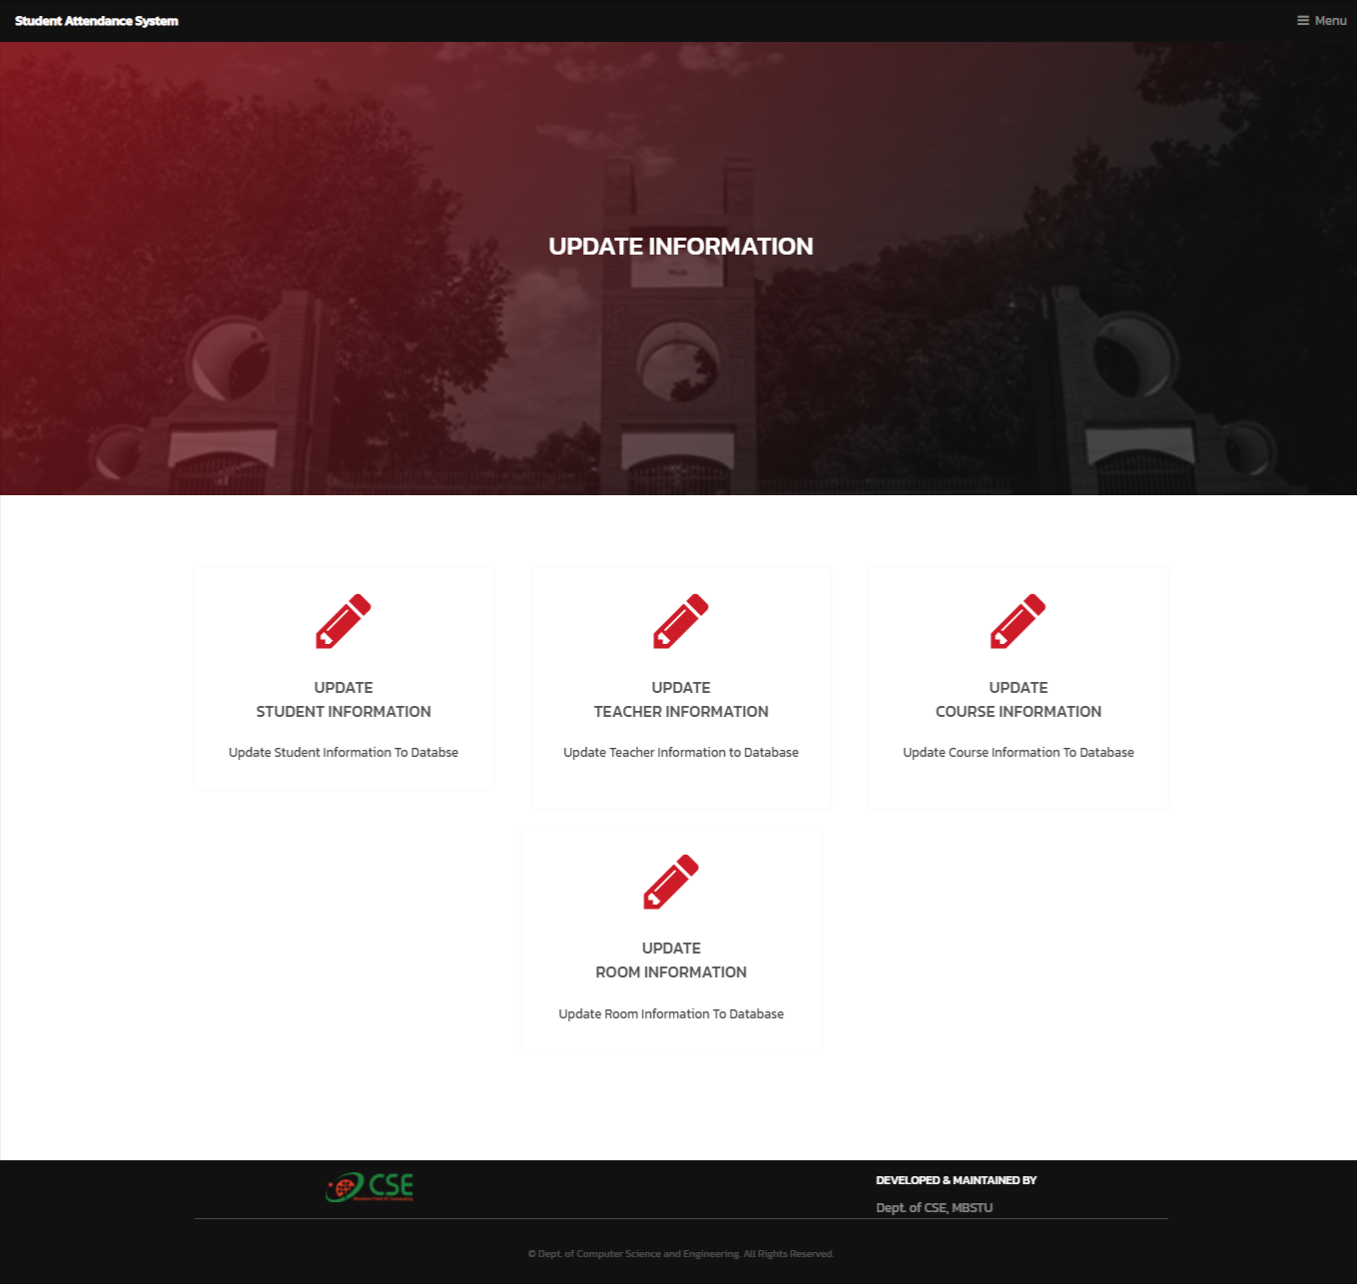

##### Figure 7.2.5: Update Information

### Assign Teacher

Admin can assign teachers to courses.

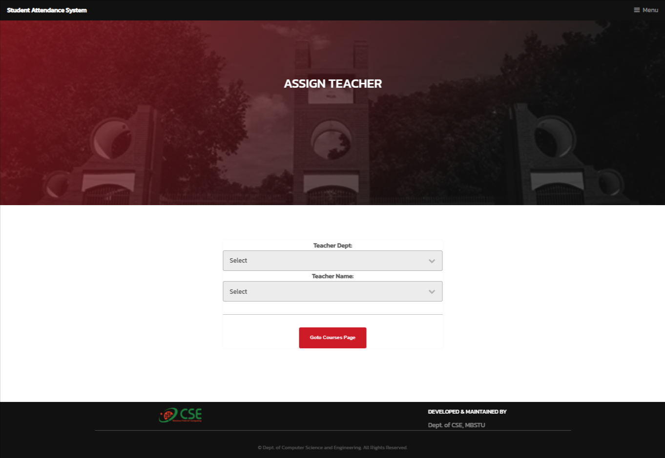

##### Figure 7.2.6: Assign Teachers

### Browse Information

Adin can view teacher, student and course information here.

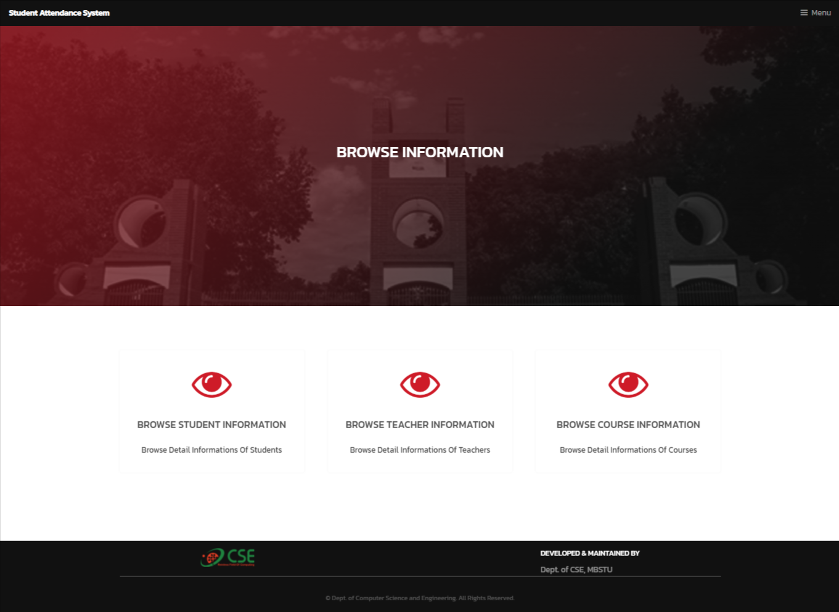

##### Figure 7.2.7: Browse Information

### Set/Update Teacher Priority

In this section admin can set or update teacher priority.

##### C:\Users\shahr\Downloads\Update-Teacher-Priority (1).pngFigure 7.2.8: Set/Update Teacher Priority

### Archive Documents

In this section admin can create folders upload files and view/delete files.

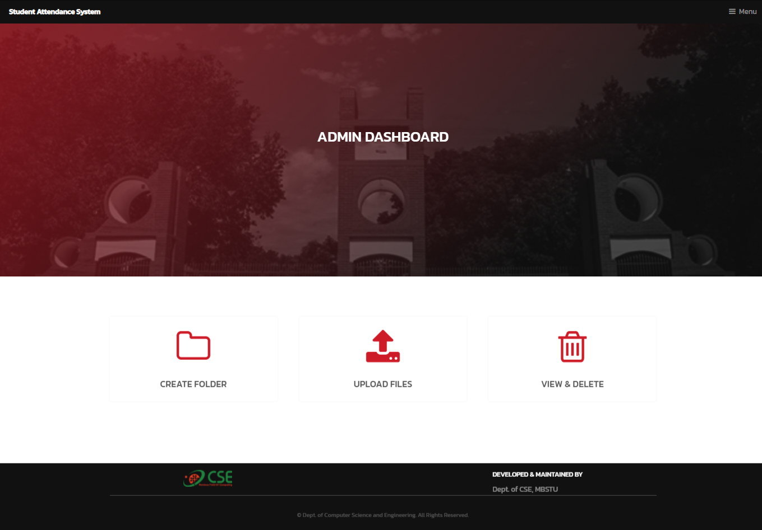

##### Figure 7.2.9: Set/Update Teacher Priority

## Teacher Dashboard

After a successful login a teacher dashboard will be shown.

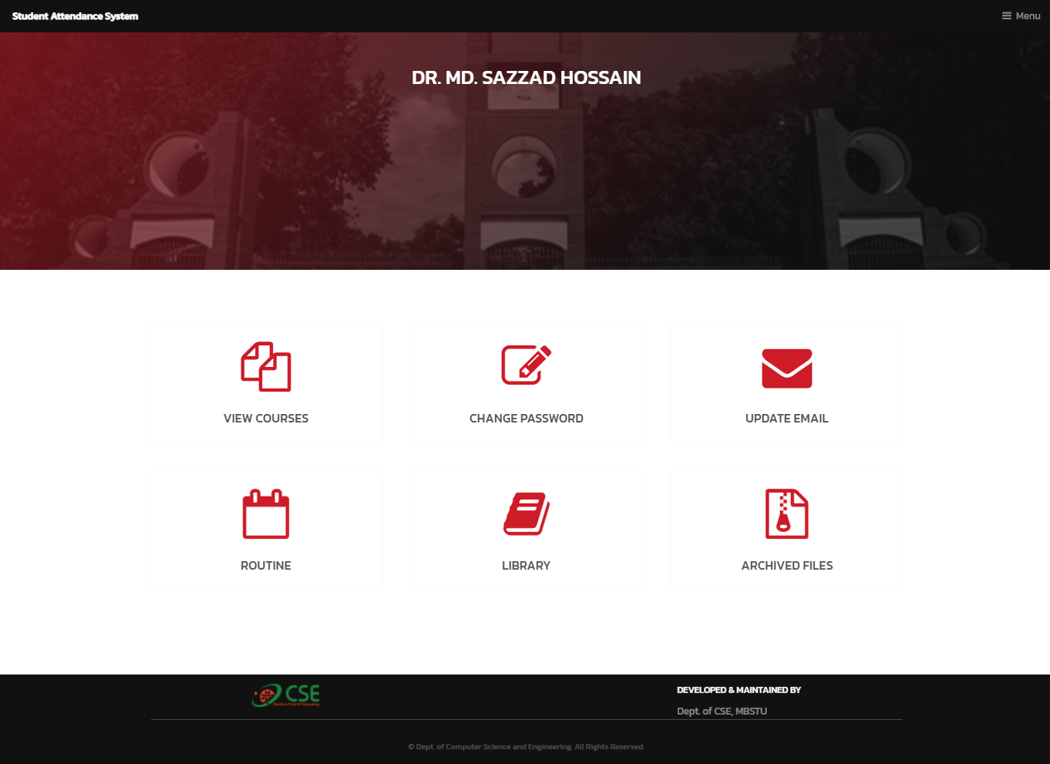

##### Figure 7.3.1: Teacher Dashboard

### Teacher Assigned Courses

Teacher can view assigned courses.

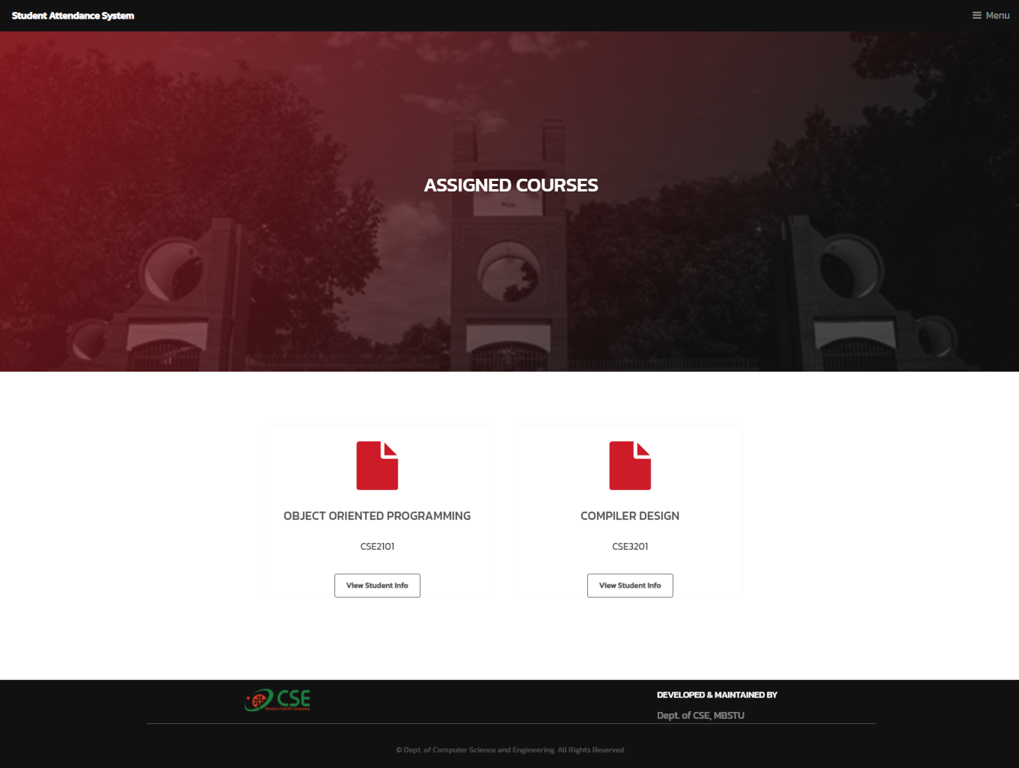

##### Figure 7.3.2: Courses

### Create Class

Teacher can create class to a assigned course.

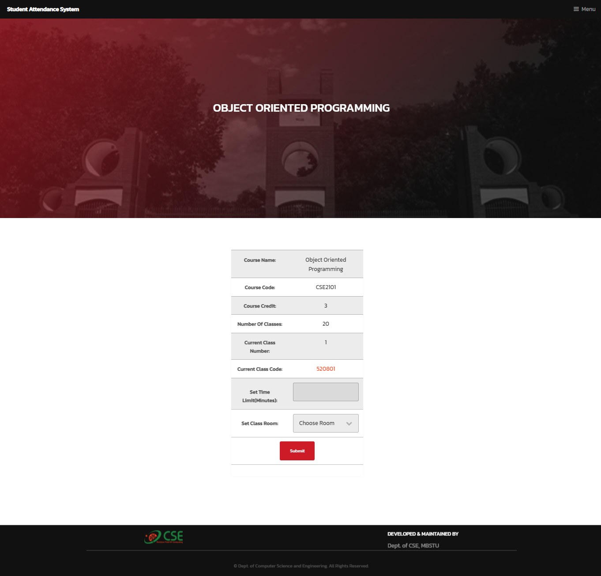

##### Figure 7.3.3: Create Class

### View Students Attendance Results

Teacher can view all student’s attendance results as well as percentage. Teacher can also view a specific students attendance information and can download results in excel file.

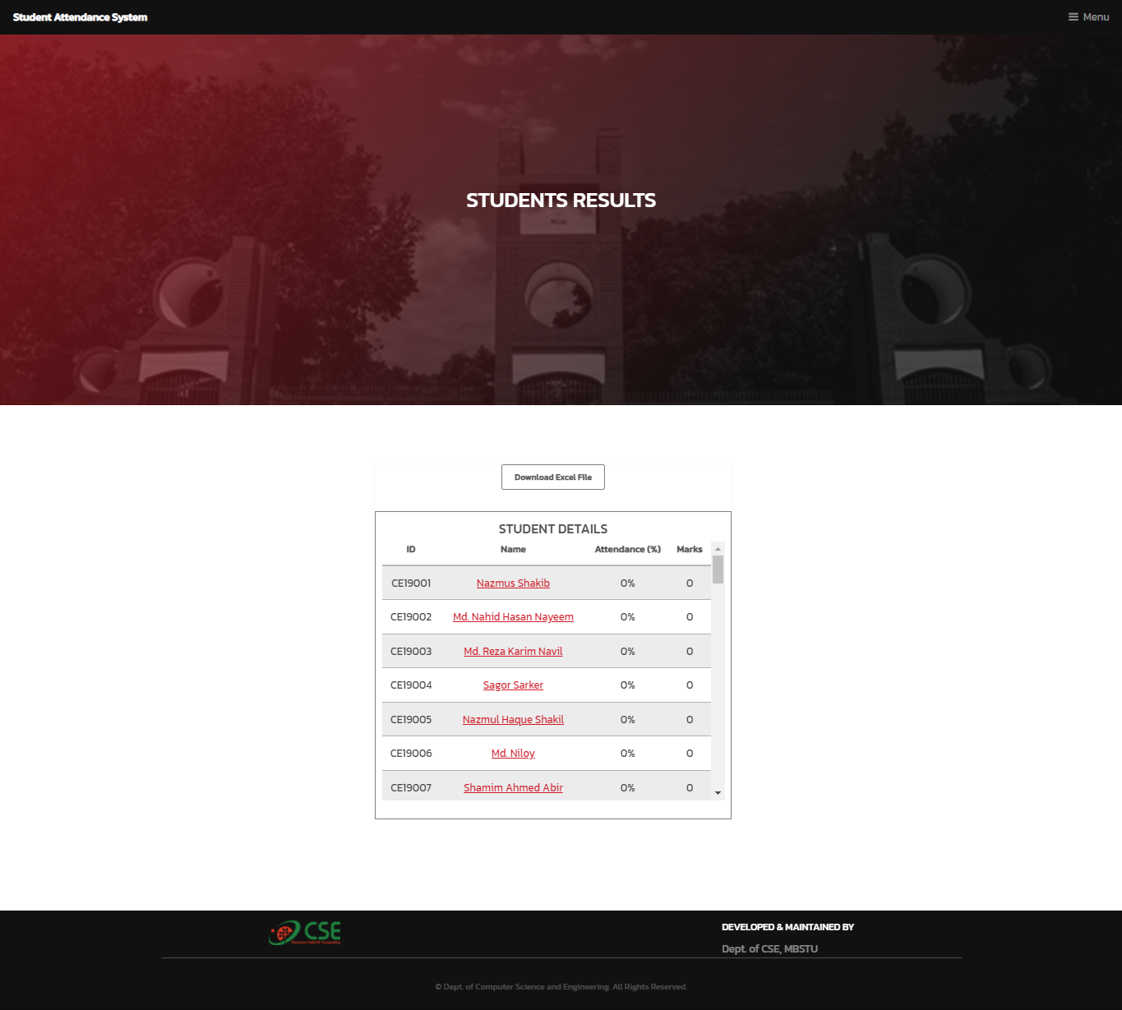

##### 

##### Figure7.3.4: Students Result

### Routine

Teacher can set or view routine. Every teacher have to follow the teacher priority list to set routine.

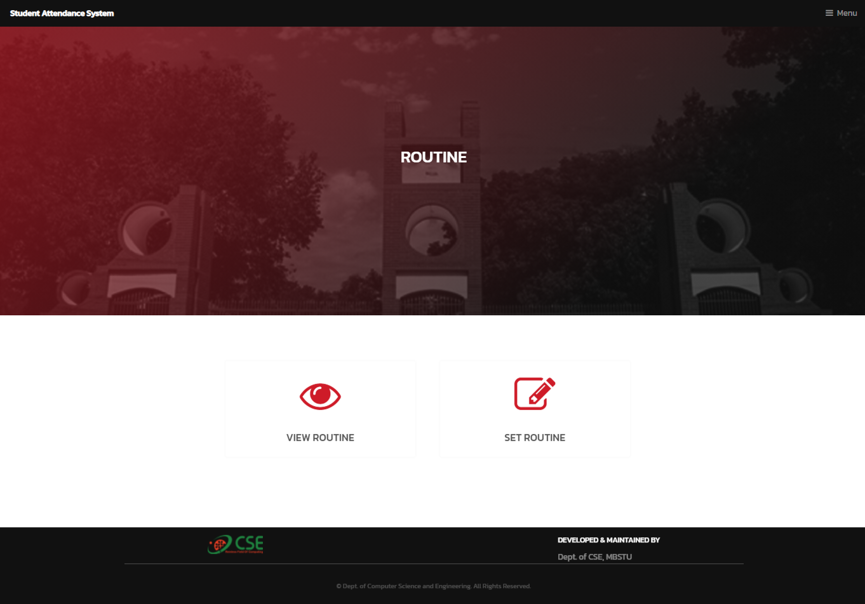

##### Figure 7.3.5: Routine

### Archived Files

Teachers can download archived files by admin.

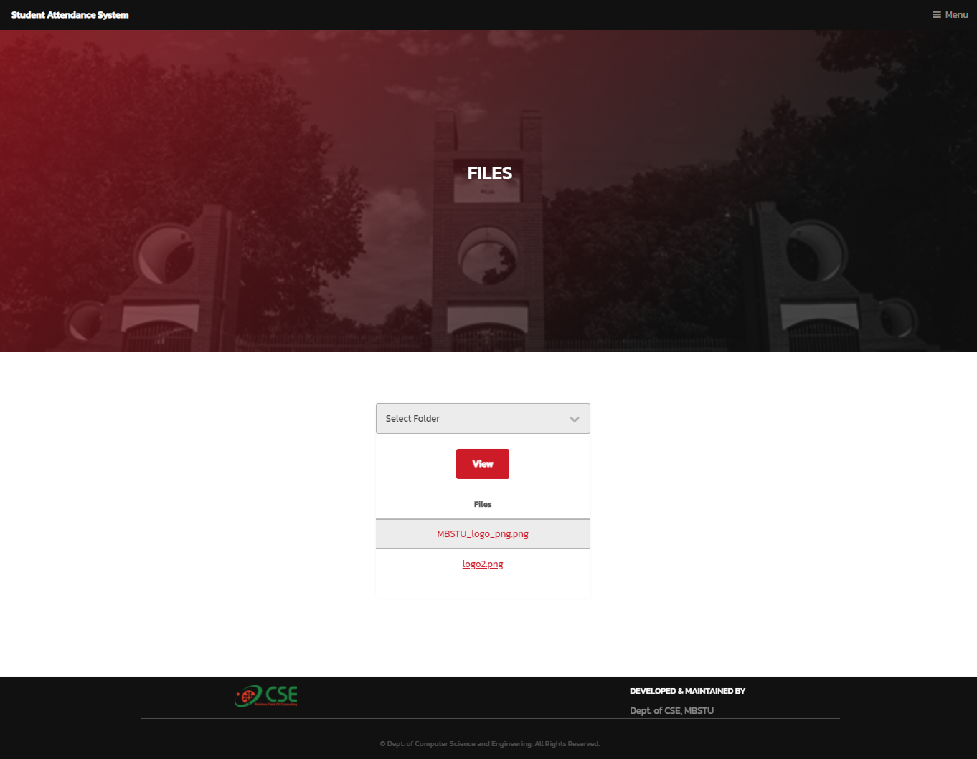

##### Figure 7.3.6: Archived Flies

## Student Dashboard

After a successful login a student dashboard will be shown.

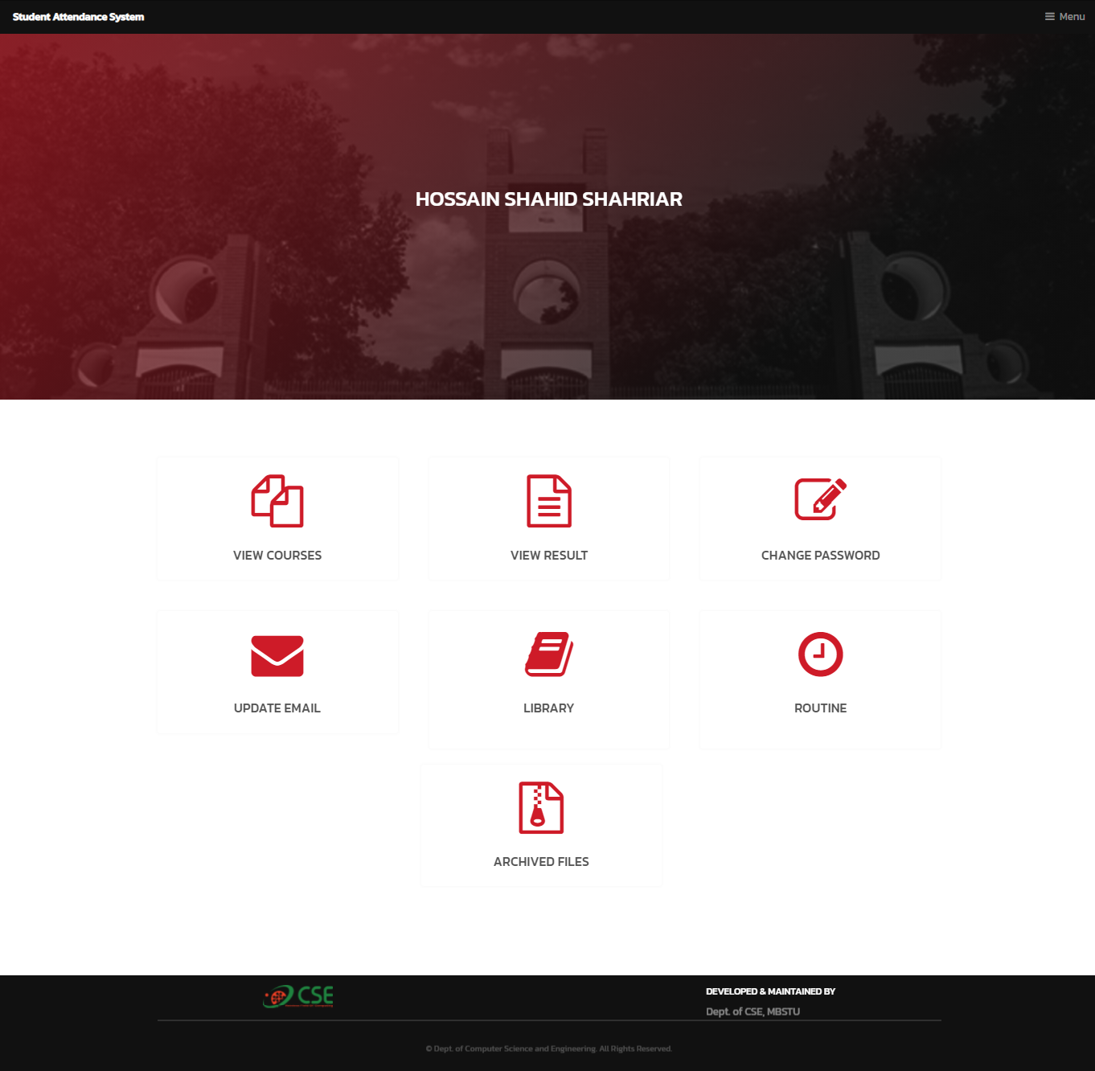

##### Figure 7.4.1: Student Dashboard

### Courses

Student can view all his/her courses.

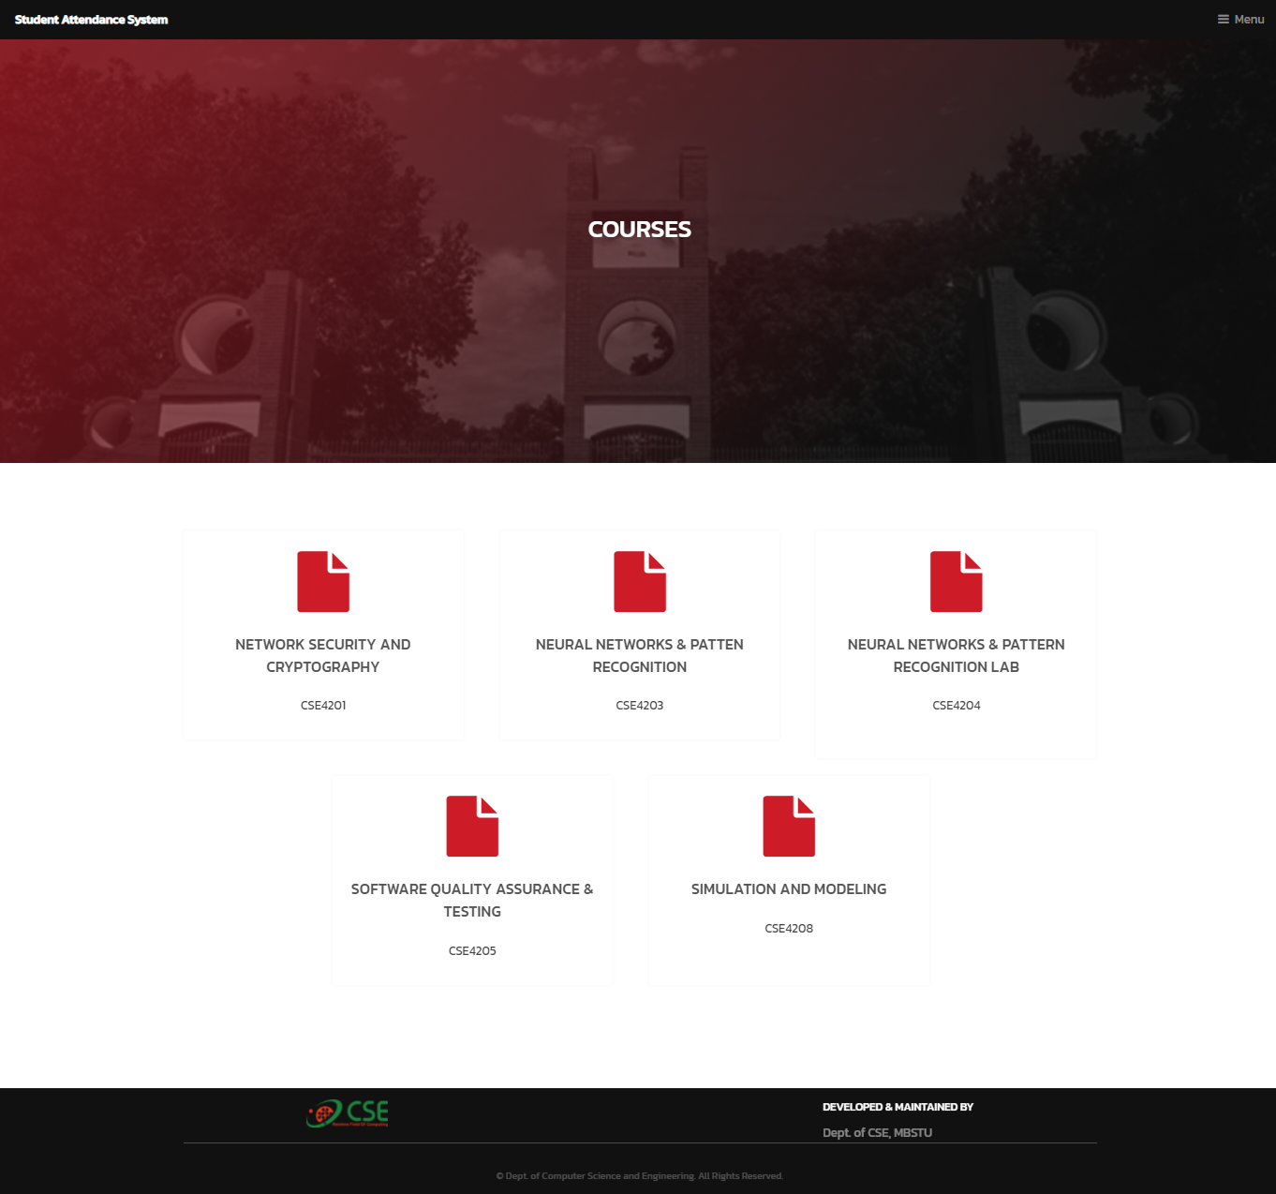

##### Figure 7.4.2: Courses

### Attendance Page

Student can give attendance for a particular class.

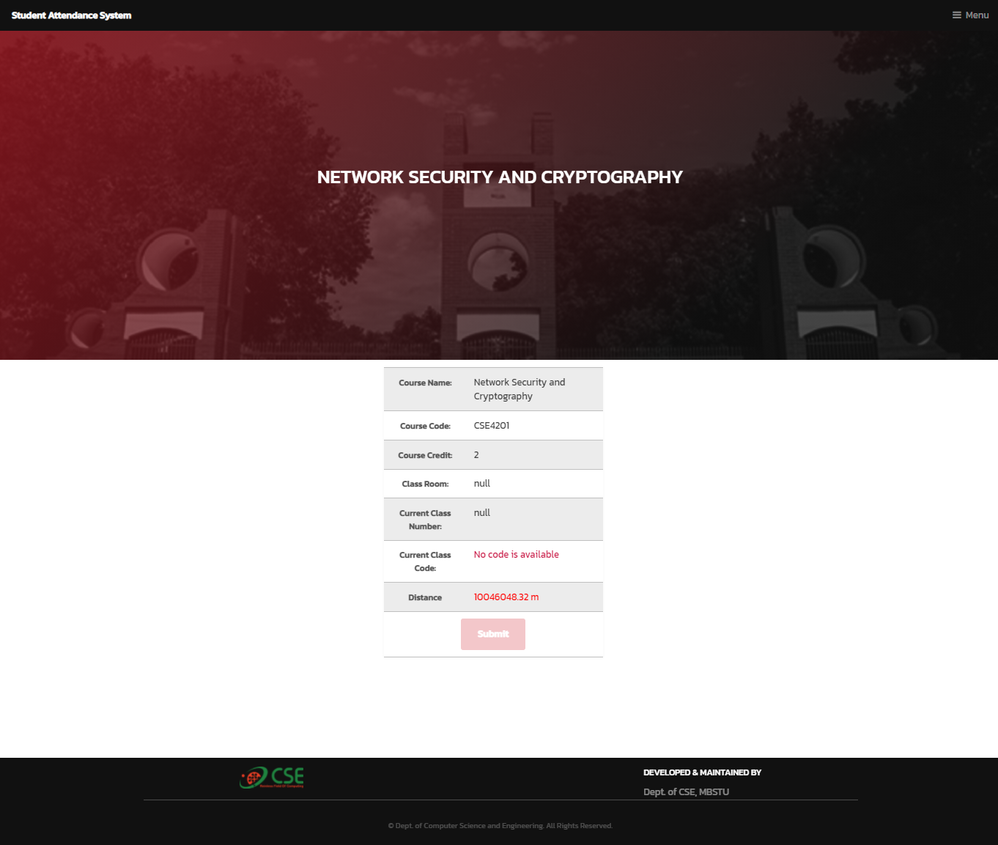

##### Figure 7.4.3: Attendance Page

### Result Page

Student can view attendance result for every courses.

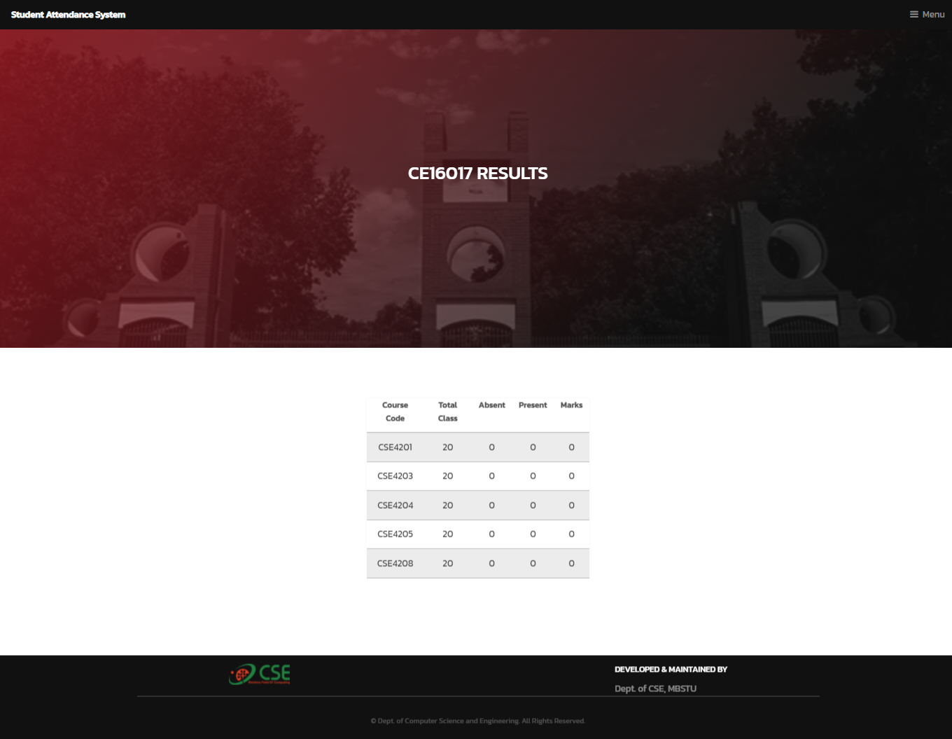

##### Figure 7.4.4: Result Page

### library

Student can view department library.

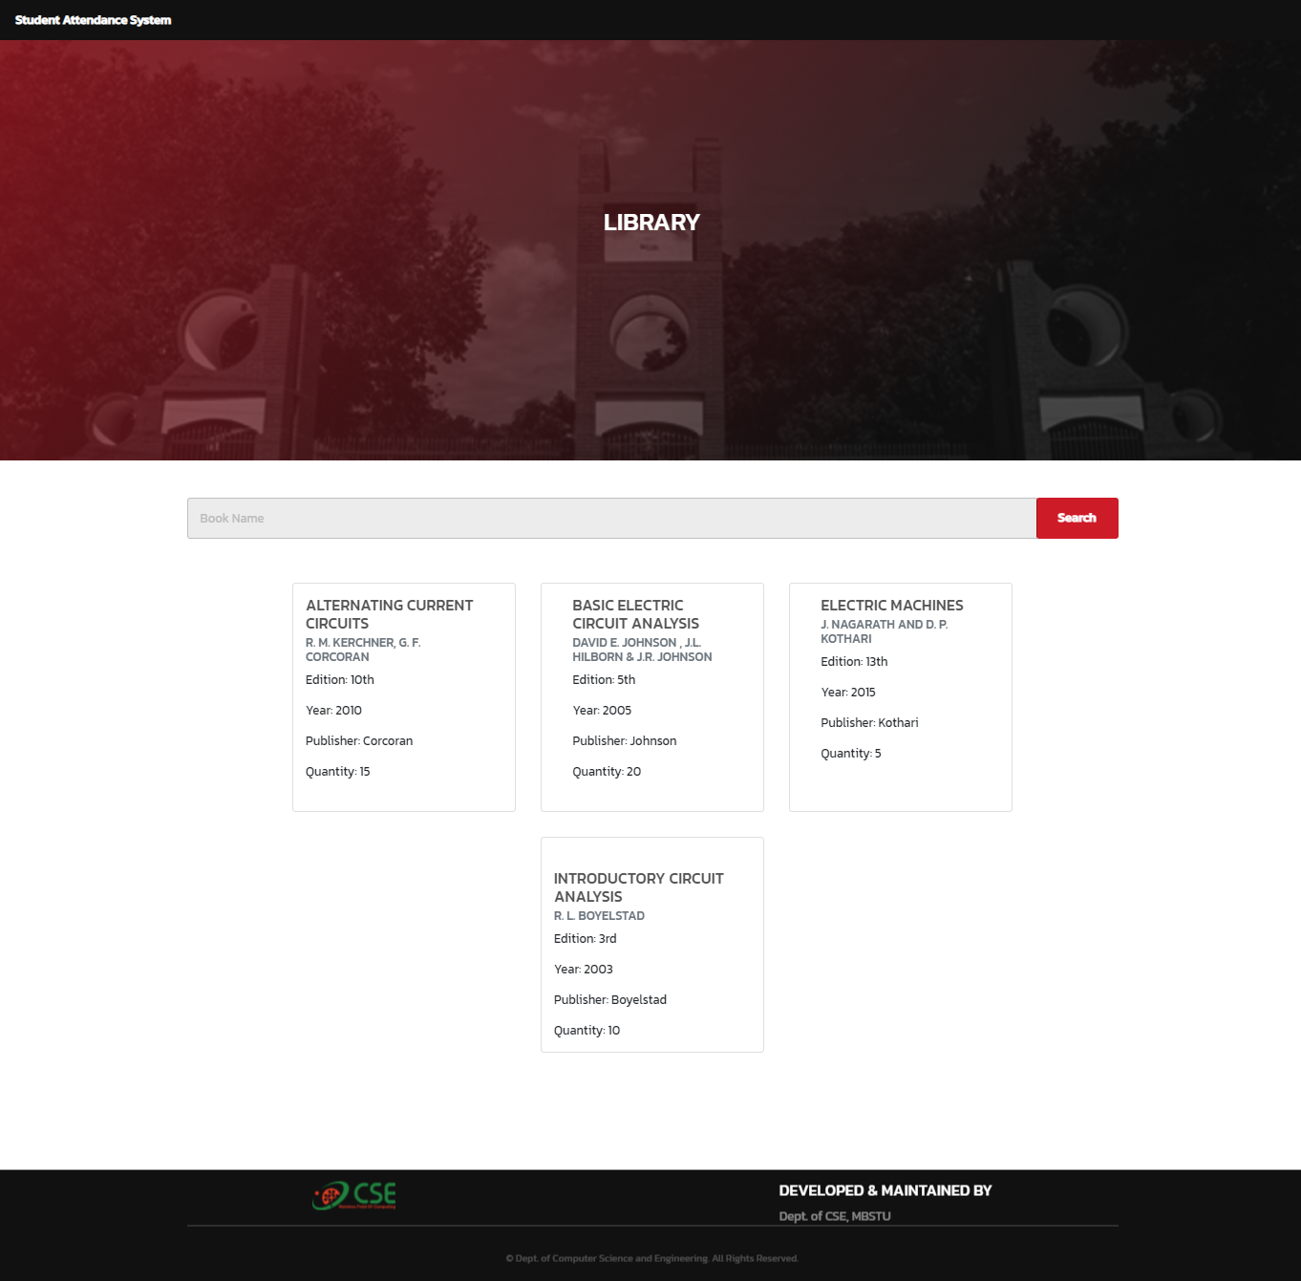

##### Figure 7.4.5: Library

### Routine

Student can view routine.

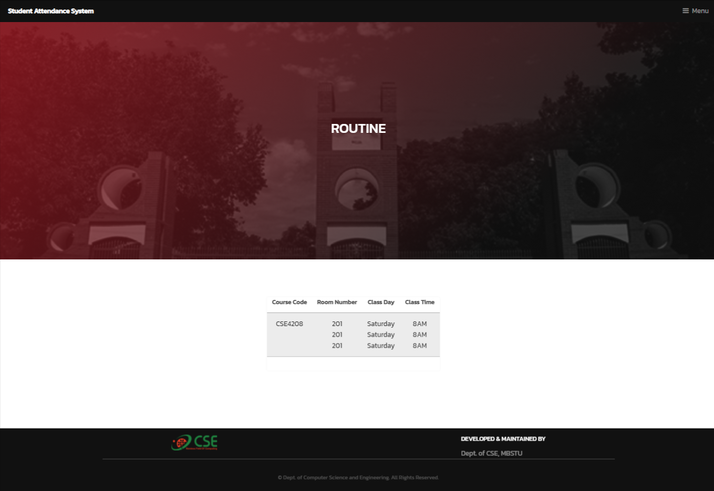

##### Figure 7.4.6: Routine

### Archived Files

Students can view archived files.

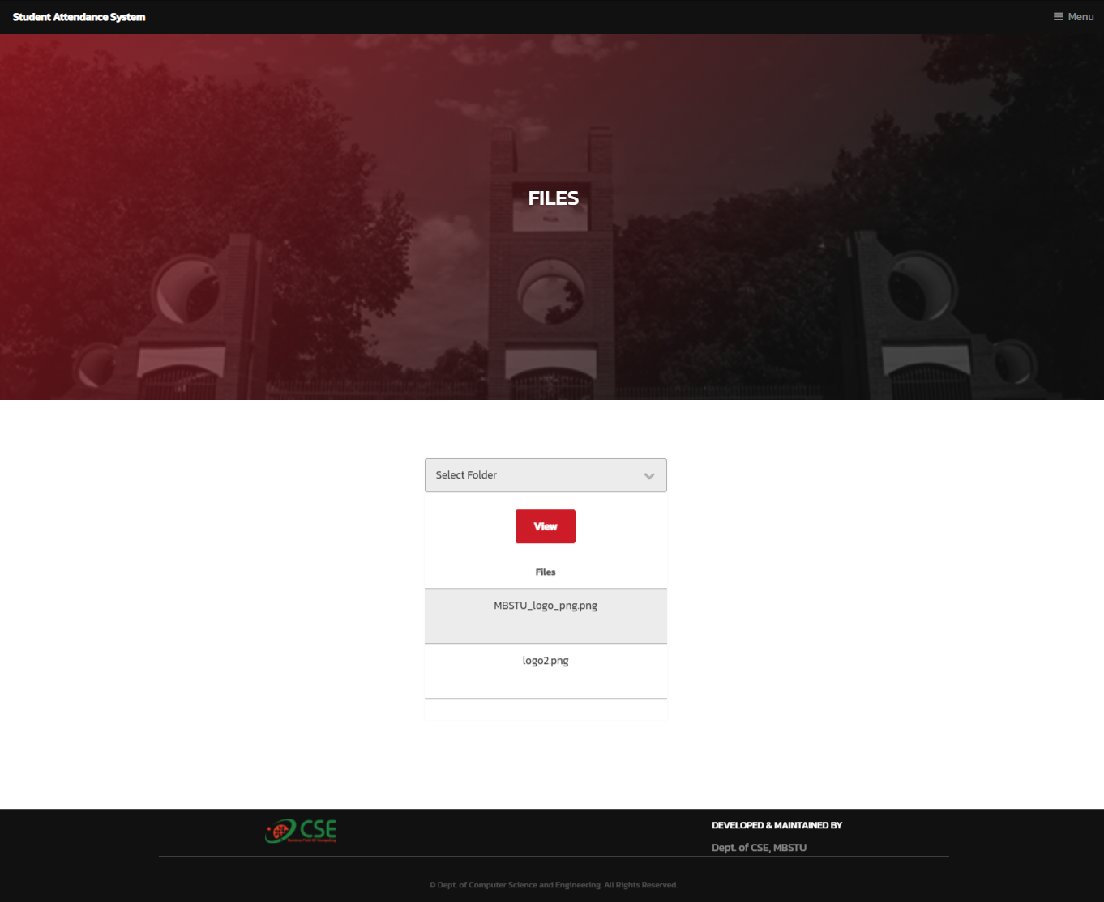

##### Figure 7.4.7: Archived Flies

## Library Dashboard

After a successful login a library dashboard will be shown.

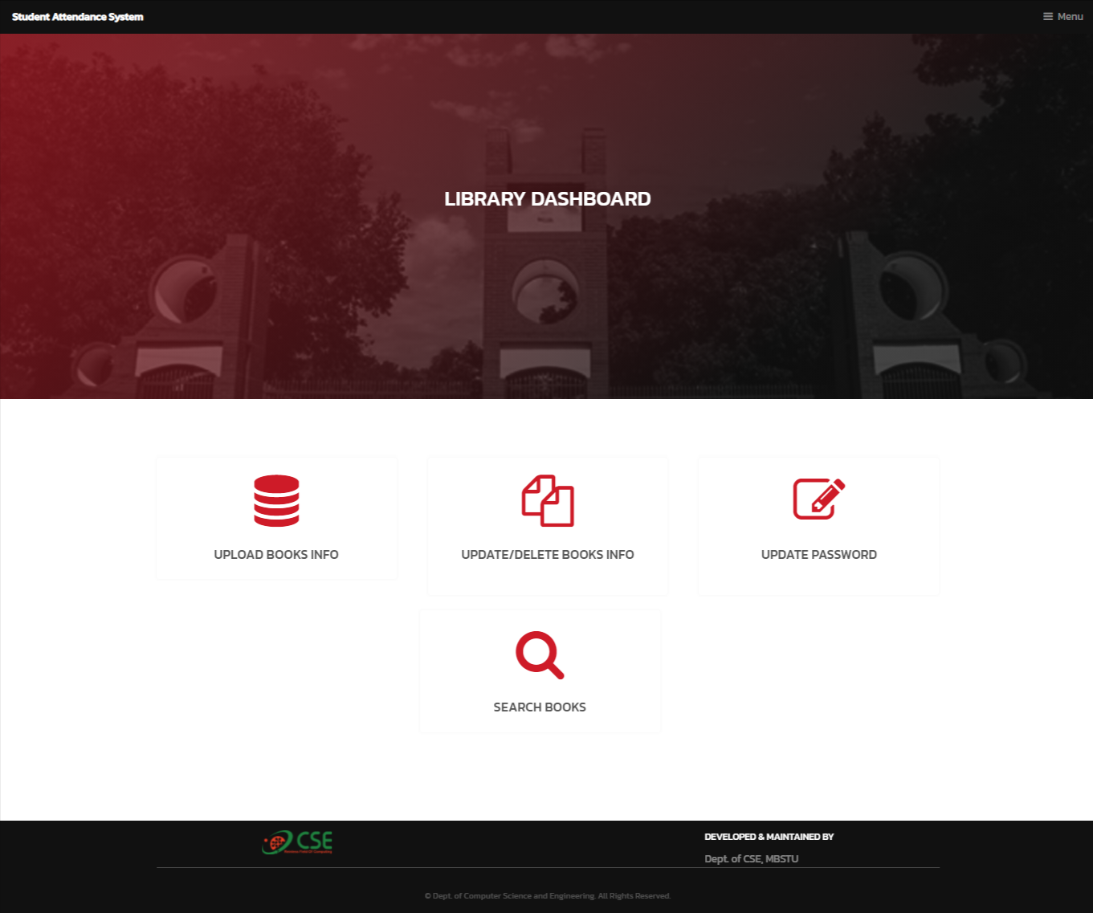

##### Figure 7.5.1: Library Dashboard

### Upload Page

Librarian can upload books information as excel file.

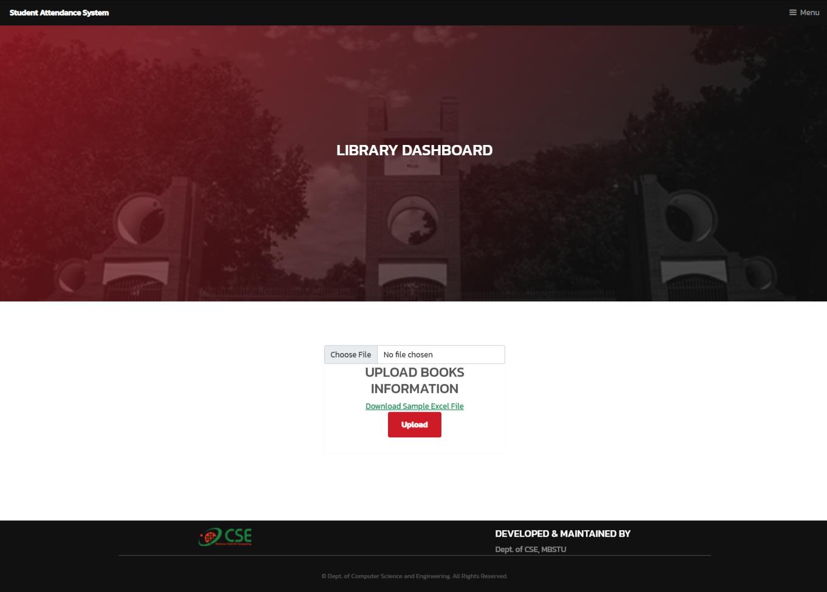

##### Figure 7.5.2: Upload Page

### Update/Delete Page

Librarian can update or delete books information.

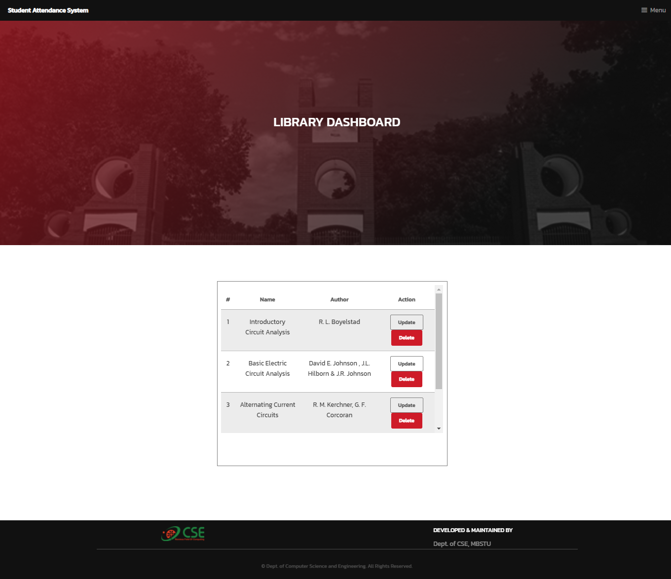

##### Figure 7.5.3: Update/Delete page

# **Limitations, Future Work and Conclusion**

## Limitations

Throughout our work on the topic, a few areas were overlooked. Some of those limitations can be pretended as follows:

* A backup database is not used in this project that would be added in a near future.
* None other than registered users can access information in this project.
* There are a few drawbacks in the database design due to our limited experience and knowledge in the database field. So we have to work more with efficient database design and implementation.

## Future Works

In the future, we can integrate with dozens of programs and applications, which makes our users even more convenient and better. For example

* We can automate the routine system more dynamically
* Department staff’s module can be added.
* Database schema can be more enrich.
* User Registration can be added.
* User Password reset option can be added.

## **Conclusio**n

Online Department Management System is a great management system for any institution that is looking to:

* Automate attendance system and class management.
* Reduce paperwork and time.
* Digitalize management system.
* Automate attendance result system.

# References

[1] Kartiki Datakar, “Online College Management System,” International Journal of Computer Science and Mobile Computing, Vol. 5, Issue 4, April 2016.

[2] C.J. Date “An Introduction to Database System”, Ed. 7th. India: Pearson Education (Singapore). Pte. Ltd, 2002.

[3] Lalit Joshi, “A Research Paper on College Management System”, International Journal of Computer Applications, Vol.122, Issue 11, July 2015.

[4] S. Jeyalatha, B. Vijayakumar,and G. S. Wadhwa, "Design and implementation of web based application for relational data maintenance in an university environment," in Proc. 2011 International Conference and Workshop on Current Trends in Information Technology , Dubai,pp. 105-112.

[5] An Efficient Automatic Attendance System Using Fingerprint Reconstruction Technique. Josphineleela. R Research Scholar Department Of Computer Science And Engineering

[6] S. R. Bharamagoudar, Geeta R . B. and S. G. Totad, "Web Based Student Information Management System".